BIRLA INSTITUTE OF TECHNOLOGY & SCIENCE, PILANI

**DERIVATIVES & RISK MANAGEMENT (ECON F354)**

 **Group -4**

**Option Trading Strategies**: ADANIENT

|  |  |
| --- | --- |
| **Name** | **ID** |
| Tejasvini Goel | 2022A7PS1672H |
| Aryan Rae | 2022A4PS0875H |
| Kolasani Amit Vishnu | 2021A7PS0151H |
| Tanishq Jain | 2022B3AA0608H |
| Manasvi Chervela | 2022A7PS2015H |
| Upanshu Sharma | 2022B1A71751H |
| Rushi Patel | 2022A7PS1382H |
| Nausheen Tabassum | 2022A5PS1247H |

**TABLE OF CONTENTS**

1. About ADANIENT
2. Technical Analysis
3. Jade Lizard
4. Short Straddle
5. Bull Call Spread
6. Call Ratio Backspread
7. Long Iron Condor

# **Adani Enterprises (ADANIENT)**

## **About Adani Enterprises**

Adani Enterprises Limited is an Indian Multinational publicly-listed holding company and the flagship entity of Adani Group. Headquartered in Ahmedabad, the company operates across various sectors including energy, infrastructure, trading, and agribusiness.Its key businesses include power generation, coal mining and trading, ports, logistics, and real estate. Adani Enterprises is known for its significant investments in renewable energy, particularly solar and wind power, as well as its ownership of strategic ports such as Mundra Port in Gujarat. The company has faced scrutiny over environmental concerns related to its coal mining operations and has been involved in controversies regarding corporate governance. Despite challenges, Adani Enterprises remains a major player in India's corporate landscape, contributing to economic growth and development.

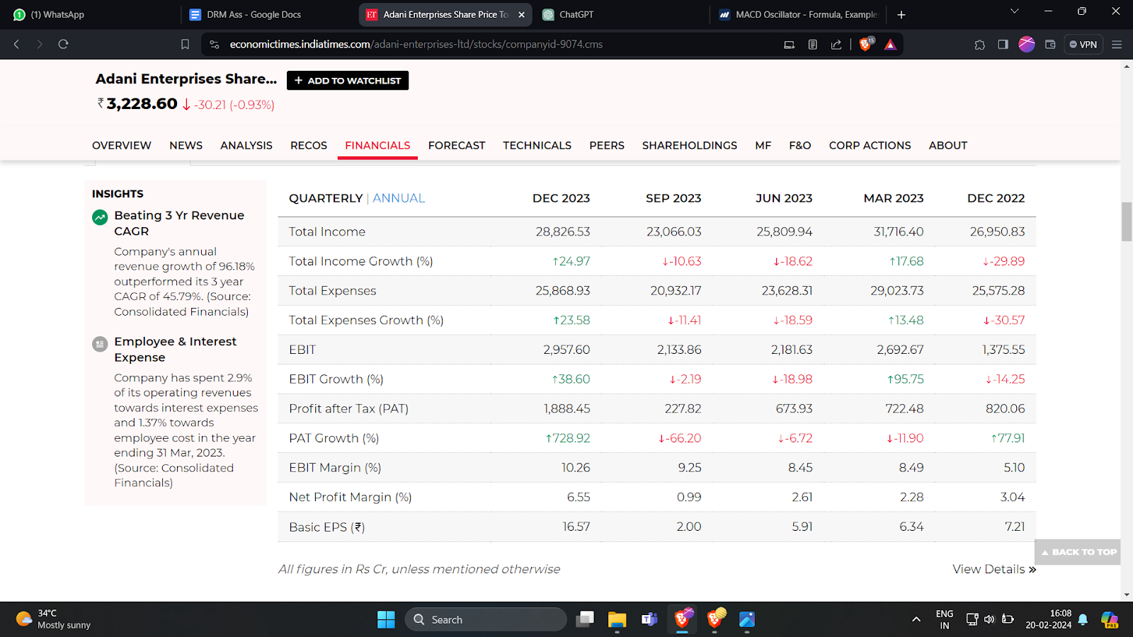

**Technical analysis:**

Throughout the year 2023, ADANIENT, the stock of Adani Enterprises, witnessed notable fluctuations in both price and volume, indicative of dynamic market conditions and investor sentiment. Despite the volatility, the company reported a robust financial performance for the fiscal year ending on March 31, 2023, with total income reaching Rs 138,175.12 Cr and profits standing at Rs 2,472.94 Cr. This solid financial performance likely contributed to investor confidence and bolstered the stock's resilience amidst market fluctuations. Notably, ADANIENT shares surged impressively by approximately 135% from their 52-week low recorded in February 2023, demonstrating a remarkable recovery and potential investor interest in the company's prospects. The stock's volume exhibited fluctuating patterns, with notable peaks observed particularly when the stock price hovered around Rs. 2500, suggesting heightened trading activity and investor participation during these periods. Such fluctuations in both price and volume underscore the dynamic nature of ADANIENT's stock and reflect the broader market dynamics and investor sentiment influencing its performance throughout the year.

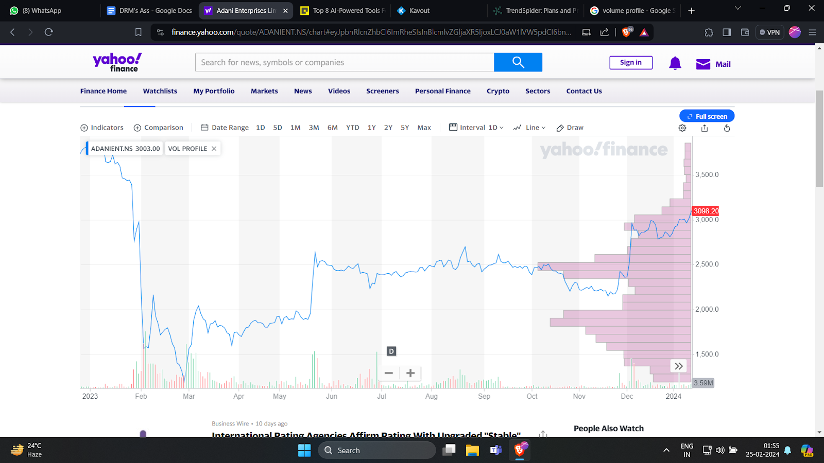

# **Technical Indicators**

## **ADX**

The Average Directional Index (ADX) is a technical analysis indicator used to measure the strength and momentum of a trend. ADX is a set of 3 lines, +DI (green), -DI (red), ADX (black).

The ADX line represents the strength of the trend. A higher ADX value suggests a stronger trend, while a lower value indicates a weaker trend or a non-trending market. The +DI and -DI lines measure the upward and downward movements respectively.

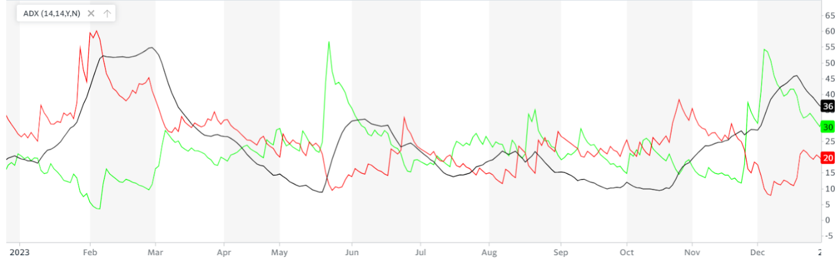

In this case, the positive directional indicator (+DI) surpasses the negative directional indicator (-DI), accompanied by an Average Directional Index (ADX) reading above 25, indicating a robust bullish trend expected to endure for 1-2 months. Although the declining ADX suggests a weakening momentum, its recent upward trend reduces the likelihood of an immediate trend reversal. This dominance of +DI underscores prevalent buying pressure, suggesting potential opportunities for traders to capitalize on upward movements.

## **Moving Averages(MA 50, MA 200)**

Moving averages (MAs) are calculated by averaging the closing price of an asset over a specific period (ex: 50 days, 100 days, 200 days etc).

* MA 50 (50 day MA)  is of a shorter time frame. It captures recent price movements and identifies shorter-term trends. It is more responsive and reacts quickly to price changes, making it useful for identifying potential support and resistance levels.
* MA 200 (200 day MA) is of a longer time frame. It considers a wider range of historical data, revealing longer-term trends. It acts as a stronger support/resistance level due to its stability.

Combined use:

* Crossovers: When the 50-day MA crosses above the 200-day MA (golden cross), it can signal a potential uptrend. Conversely, a downward crossover (death cross) might indicate a downtrend.
* Trend confirmation: Both MAs trending in the same direction (up or down) strengthens the trend signal.

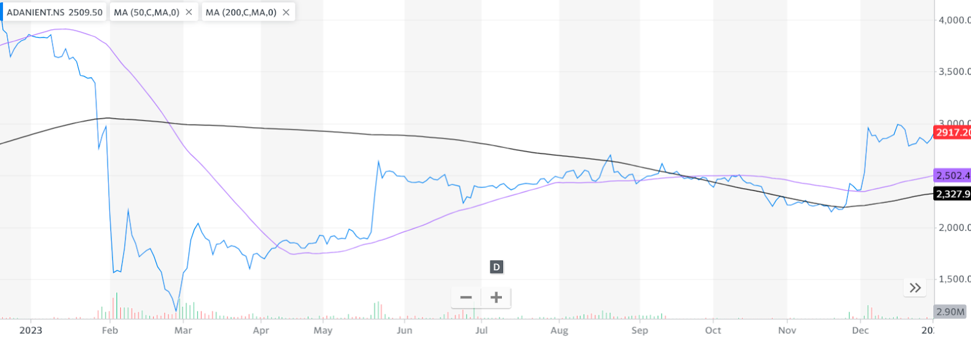

This scenario depicts a bullish trend as the 50-day moving average (MA 50) crosses above the 200-day moving average (MA 200), with both MAs on the rise. This signals recent price strength surpassing longer-term trends, prompting expectations of further price increases. The alignment indicates sustained bullish momentum.

## **Relative Strength Index (RSI)**

Relative Strength Index (RSI) is used to gauge an asset's recent price momentum and identify potential overbought or oversold conditions.

RSI oscillates between 0 and 100. It considers both upward and downward price movements over a chosen period (typically 14 days). Higher RSI values indicate stronger buying pressure, potentially suggesting an overbought condition (above 70). Lower RSI values indicate stronger selling pressure, potentially suggesting an oversold condition (below 30).

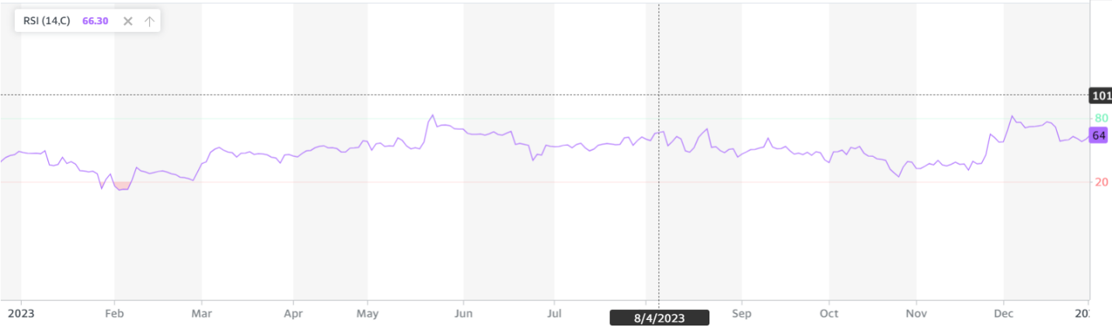

In a rising market where the RSI consistently aims to breach 70, while staying above 50, like in this scenario ,bullish momentum is evident. The RSI's positioning above 50 reflects prevailing buying pressure, signaling that average gains are outpacing losses. With the RSI persistently gravitating towards the 70 level, an indication of potential overbought conditions emerges, yet the upward trajectory of the market endorses sustained bullish sentiment.

**Option Strategies**

**1. Jade Lizard (1 Jan 2024- 25th Jan 2024) (slightly bullish expectations)**

A Jade Lizard is a relatively simple and popular option strategy best deployed when the trader has a neutral (i.e., sideways or range-bound) to bullish view of a given security. The Jade Lizard strategy combines a short put and a short call spread.

**What type of investor should use this strategy**

It’s a relatively simple move best suited for when a trader has a neutral to bullish outlook for a given security and markets are [range-bound](https://www.investopedia.com/terms/r/rangeboundtrading.asp) and moving [sideways](https://www.investopedia.com/terms/s/sidewaysmarket.asp), but with potential to move higher. The strategy is a premium-only option trade, meaning that the maximum gain is the amount of premiums taken in when implementing the strategy.

**Strategy Positions Spot price as of 1Jan’24 is Rs 2917.2 (STo=2917.2)**

-Sell 2800PE at premium=90.5 (OTM) (K1=2800) (K1<STo)

-Sell 3000CE at premium=140.05 (OTM) (K2=3000) (K2>STo)

-Buy 3200CE at premium=85.65 (OTM) (K3=3200) (K3>STo)

-K3>K2 since we need to ensure that premium is received in the call positions

**Payoff Matrix** **Cost=premium paid=-P1-P2+P3=-144.9**

**Net cost=-144.9*300=** -₹43470

**(net premium is received or net negative cost)**

|  |  |  |  |  |
| --- | --- | --- | --- | --- |
| **Criteria** | **ST<=K1** | **K1<ST<=K2** | **K2<ST<=K3** | **ST>K3** |
| **Short Put(K1)** | ST-K1 | 0 | 0 | 0 |
| **Short Call(K2)** | 0 | 0 | K2-ST | K2-ST |
| **Long Call(K3)** | 0 | 0 | 0 | ST-K3 |
| **Payoff** | ST - K1 | 0 | K2-ST | K2-K3<0 |
| **Profit** | ST-K1-Cost=ST-2655.1 | 0-Cost=144.9 | K2-ST-Cost=3144.9-ST | K2-K3-Cost=-55.1 |

**Profit Diagram**

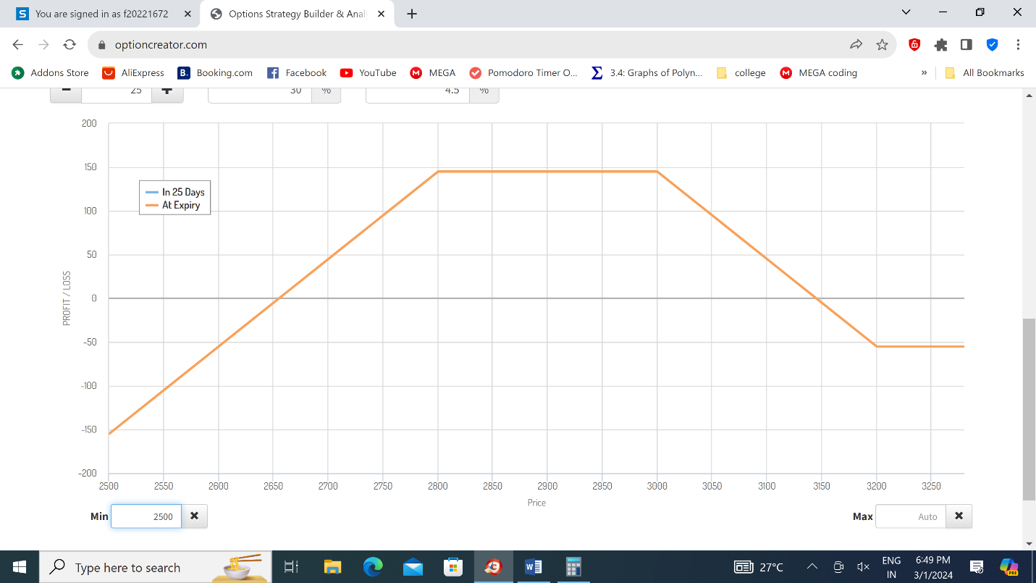

**Calculations**

|  |  |
| --- | --- |
| Lot Size | 1 Lot = 300 Options |
| Maximum Profit | -net cost=₹43470 |
| Maximum Loss | Unlimited |
| Break-Even Price | ₹2655.1, ₹ 3144.9 |

**Realized profit/loss**

Actual spot price at maturity=Rs. 2893.6 (K1<ST<K2)

Profit=-Cost=₹43470

Thus, our strategy proved to be **profitable** in nature.

**2. Short Straddle (1 Jan’24-25th Jan’24) (slightly bullish expectations)**

Setting up a short straddle is straightforward, unlike buying the ATM Call and Put options, like in Long Straddles. We just have to sell the ATM. Call and Put option. The short strategy is set up for a net credit, as the premium is received into our account when selling the ATM options.

**What type of investors can use this strategy?**

This strategy is best for investors who think the spot would have low volatility and be non-directional until the next expiration. This is one of the most preferred strategies among option sellers.

**Traded Options- Spot price as of 1Jan’24 is Rs 2917.2 (STo=2917.2)**

-Sell 2900CE at premium=179.55 (OTM) (K=2900) (K<STo)

-Sell 2900PE at premium=136.5 (OTM) (K=2900) (K>STo)

Cost=-(179.55+136.5)=-316.05

Net cost=-(316.05)*300 =-₹94815 (net negative cost, or premium received)

2900CE is OTM, 2900PE is OTM

**Profit-Payoff Matrix:**

|  |  |  |
| --- | --- | --- |
| **Criteria** | ST<=K | ST>K |
| **Short Call (2900)** | 0 | K - ST |
| **Short Put (2900)** | ST-K | 0 |
| **Payoff** | ST-K | K - ST |
| **Profit** | ST - K – Cost=ST-2583.95 | K - ST- Cost=3216.05-ST |

**Profit vs Price Graph:**

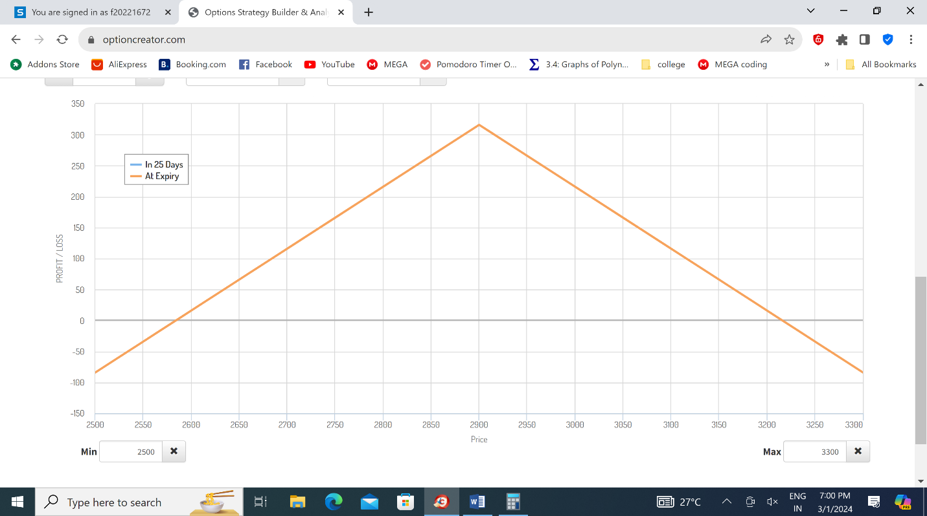

**Calculations :**

|  |  |
| --- | --- |
| **Lot Size** | 1 Lot = 300 Options |
| **Maximum Profit** | -net cost=₹94815 |
| **Maximum Loss** | Unlimited |
| **Break-Even Prices** | ₹ 2583.95 and ₹ 3216.05 |

**Results of the Trade:**

The stock closed at ST=**₹**2893.6 on the expiry date, which lies in the Profit range of this trade. (ST<K)

Realized profit=300*(ST-K-Cost)=300*(2893.6-2900+316.05)=Rs. 92895

Thus our trade proves to be profitable in nature.

**3. Bull Call Spread (1 Jan’24- 29 Feb’24) (moderately bullish expectations)**

This strategy involves buying a call option at a lower price (long call) and selling another at a higher price (short call) on the same stock, both expiring at once. This limits potential profit but also caps your risk compared to buying a single call. Think of it as buying a bet on a moderate price increase with a built-in safety net.

**What type of investors should use this strategy?**

Bull call spreads are ideal for investors cautiously optimistic about a stock's moderate rise. They involve buying a lower strike call (limited profit) and selling a higher strike call (collecting premium) to limit risk. This strategy suits risk-averse investors seeking income or new option traders wanting a controlled entry. However, highly bullish investors might prefer single calls for potentially higher gains.

**Strategy positions**

The spot price as of 1st Jan 2024 was *Rs.2917.2.*

Buy 2850 CE at 1st Jan at a premium of *Rs.185.80* (ATM). (data was available for this at the closest value for ATM) (k1=2850)

Sell 3300 CE at 1st Jan at a premium of *Rs.148.00* (OTM). (k2=3300)

Net cost= P1-P2=*Rs. 37.8.*

**Payoff matrix for bull call spread**

|  |  |  |  |
| --- | --- | --- | --- |
| **Criteria** | **ST < K1**  **ST < 2850** | **K1<= ST < K2**  **2850 <= ST < 3300** | **ST >= K2**  **ST >= 3300** |
| **1 Long calls (K1)** | 0 | ST-K1 | ST-K1 |
| **1 Short Call (K2)** | 0 | 0 | K2-ST |
| **Payoff** | 0 | ST – K1 | K2-K1 |
| **Profit / Loss** | -Cost=-37.8 | ST – K1 – Cost=ST-2887.8 | K2-K1-Cost=412.2 |

**Profit-Payoff graph**

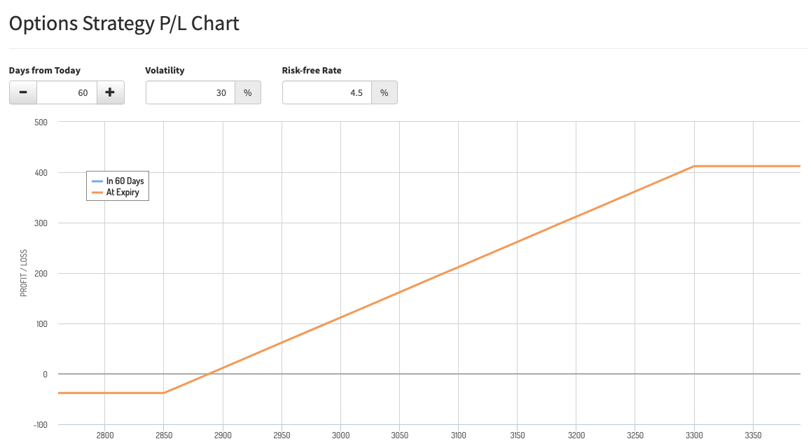

**Calculations**

|  |  |
| --- | --- |
| Lot Size | 300 options |
| Maximum profit | (412.2) * 300= Rs. 1,23,660 |
| Maximum loss | Rs37.8*300=Rs11,340 |
| Break-even price | K1+cost=Rs.2850+37.8=₹2887.8 |

**REALIZED PROFIT**

Spot price on maturity ST=3299.9 K1>ST>K2

Our profit is 300*(ST-2887.8)=**Rs.412.1*300=Rs.** **123,630**

Our strategy proved to be heavily profitable in nature.

**4.**  **Call Ratio Backspread (1 JAN 2024 - 29 FEB 2024) (moderately bullish expectations)**

* The name Call Ratio Backspread option strategy originates from the ratio and structure of the trade.
* It is a popular bullish trading technique that enables us to benefit from potential price rises. This strategy seeks to limit losses and maximize gains by combining the purchase of numerous call options with the sale of smaller numbers. It involves simultaneous buying and selling of call options.
* In this strategy we purchase two out-of-the-money call options and sell one-in-the-money-call option with the same underlying security and expiration.

**What type of investors should use this strategy**

* Investors who are moderately bullish on the security’s price and expect an increase in volatility, employ this strategy to profit from a jump in its price, while limiting losses.
* It works best when we sell slightly ITM option and buy slightly OTM option when there is ample time to expiry.

**Strategy position:  Spot price as of 1st Jan’24 is ₹ 2917.2 (STo = ₹ 2917.2)**

* Buy 2x ₹3000 CE at premium (P1) = ₹241 (OTM) (K1=3000) (K1>STo)
* Sell ₹2900 CE at premium (P2) = ₹284.95 (ITM) (K2=2900) (K2<STo)

CoS = 2P1 - P2 = ₹197.05 (outflow)

**Payoff Matrix**

|  |  |  |  |
| --- | --- | --- | --- |
| **Criteria** | **ST < K2**  **ST < 2900** | **K2 <= ST < K1**  **2900 <= ST < 3000** | **ST >= K1**  **ST >= 3000** |
| **2 Long calls (K1)** | 0 | 0 | 2(ST - K1) |
| **Short Call (K2)** | 0 | K2 - ST | K2 - ST |
| **Payoff** | 0 | K2 - ST | ST + K2 - 2K1 |
| **Profit / Loss** | -CoS  =-197.05 | K2 - ST - CoS  =2702.95 - ST | ST + K2 - 2K1 - CoS  =ST - 3297.05 |

**Profit Diagram**

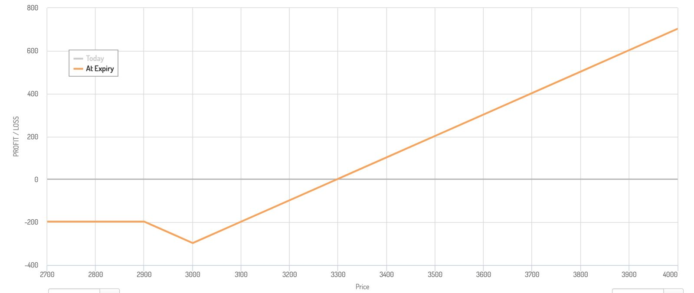

It is interesting to note that Rs.2702.95 **doesn’t** form a breakeven point due to it **not belonging** in the range **K2<=ST<=K1**

**Calculations**

|  |  |
| --- | --- |
| Lot Size | 1 Lot = 300 Options |
| Maximum Profit | Unlimited |
| Maximum Loss | (3000-2702.95)*300=297.05 x 300 = ₹89,115 |
| Break - Even Price | ₹3297.05 |

**Results of the Trade:**

ST at maturity (29 feb)=Rs.3299.9>K1

**Realized Profit:**

Profit=lot size*(ST-3297.05)=300*2.85=Rs.855

Thus our strategy proved to be profitable in nature

5. **LONG IRON CONDOR STRATEGY (1 Jan 2024- 29 Feb 2024) (moderately bullish expectations)**

This is a neutral strategy involving low risks designed to profit from low volatility in the price. It involves simultaneously buying and selling four different options contracts with the same expiration date but differing strike prices. Investors profit from the premium income generated from selling options while limiting potential losses with the options they purchase.  This is beneficial for sideways or range-bound markets.

**What type of investor should use this strategy?**

The long iron condor strategy is commonly used by options traders who have a neutral outlook on the market or a specific asset. This strategy is suitable for investors who are comfortable with limited profit potential and limited risk, as well as those who prefer to capitalize on premium income rather than directional movements in the underlying asset's price.

**Strategy Positions**

Expectations have been formed as of 31st December 2023. The Spot Price as of 1st January 2024 is **₹** 2917.2.

Sell 2850PE at premium = 626.15 (OTM) (K1 = 2850, K1<ST)

Buy 2900PE at premium = 663.25 (ATM) (K2 = 2900, K2<ST)

Buy 2950CE at premium = 162.35 (OTM/ATM) (K3 = 2950, K3>ST)

Sell 3000CE at premium = 212 (OTM) (K4 = 3000, K4>ST)

**Theoretical Payoff MatrixK3**

Premium received(inflow)=P1-P2-P3+P4 = Rs.12.55, Net premium received

|  |  |  |  |  |  |
| --- | --- | --- | --- | --- | --- |
| **Criteria** | **ST<=K1** | **K1<ST<=K2** | **K2<ST<=K3** | **K3<ST<=K4** | **ST>K4** |
| **Short put (K1)** | ST-K1 | 0 | 0 | 0 | 0 |
| **Long put (K2)** | K2-ST | K2-ST | 0 | 0 | 0 |
| **Long call (K3)** | 0 | 0 | 0 | ST-K3 | ST-K3 |
| **Short call (K4)** | 0 | 0 | 0 | 0 | K4-ST |
|  |  |  |  |  |  |
| **Payoff** | K2-K1 | K2-ST | 0 | ST-K3 | K4-K3 |
| **Profit/Loss** | K2-K1+PT=62.55 | K2-ST+PT=2912.55-ST | PT=12.55 | ST-K3+PT=ST-2937.45 | K4-K3+PT=62.55 |

**Net Profit vs Price graph**

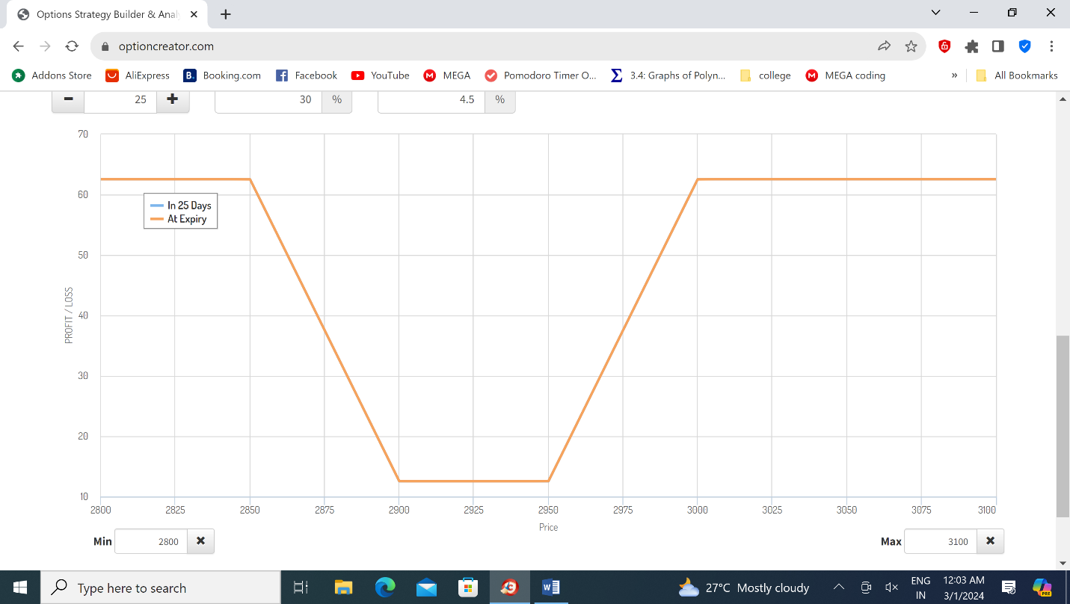

**Calculations :**

|  |  |
| --- | --- |
| Lot Size | 1 Lot = 300 Options |
| Maximum Profit | (50+12.55)*300=₹ 18,765 |
| Maximum Loss | -12.55*300=-₹3765 or minimum profit=₹3765 |
| Break-Even Price | Does not exist |

**Note:**  It is interesting to note that in this case it is mathematically impossible to be in loss in our chosen positions due to the anomaly in the premiums our options were available for.

**Results of the Trade:**

ST at maturity (29 feb)=Rs.3299.9>K4

**Realized Profit:**

Profit=lot size* (K4-K3+PT)=300*(3000-2950+12.55)=Rs.18765

Our trade proved to be profitable in nature.

______________________________________________________________________________

**References-**

1. <https://www.investopedia.com/>
2. <https://www.nseindia.com/get-quotes/derivatives?symbol=ADANIENT>
3. <https://finance.yahoo.com/quote/ADANIENT.NS/history>